
Sri Lanka Institute of Information Technology

IT3012 : Intelligent Agents – Lab 1
Y3.S1.WD.AI.01.01
Malabe Campus

Student ID - | IT24100140
Student Name - | Prathiban HTP
Module Name - | Intelligent Agents
Module Number - | IT3012
Lab Sheet Number - | 1
Lab Sheet Date - | 2026/July/24

Task 1
1.
P – Performance Measure
E - Environment
A - Actuators
S – Sensors
2.
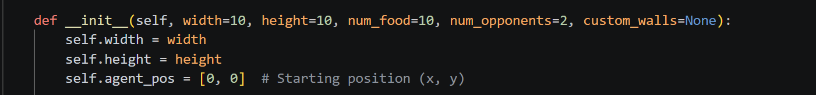
Based on this code the init – width and height represents the grid size the whole game works and the number of food is the count that the agent can reach and the number of opponents is the one there will be other agents that hunts for food just as our agent, custom walls set to none means we don’t going to spawn obstacles manually.
3.
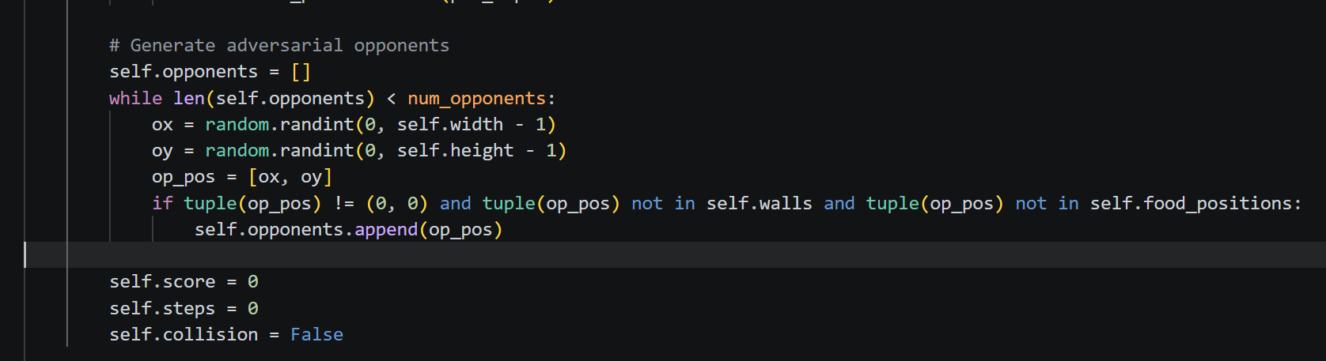
Based on the code of the opponents there is one codes like which self.collision is false those are multi agentic behaviors to avoid walls and not collide with each other

4.
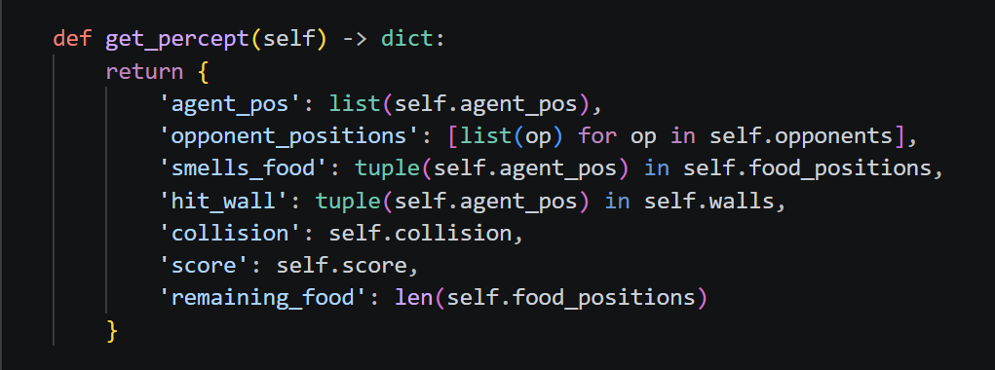
A percept sequence in artificial intelligence is the complete chronological history of all sensory inputs percepts an intelligent agent has ever received from its environment.
In this code snippet, from the perception, the agent is trying to get all the sensory information which is (ex- agent_pos – his position right now, and the opponent position and many more )
5.
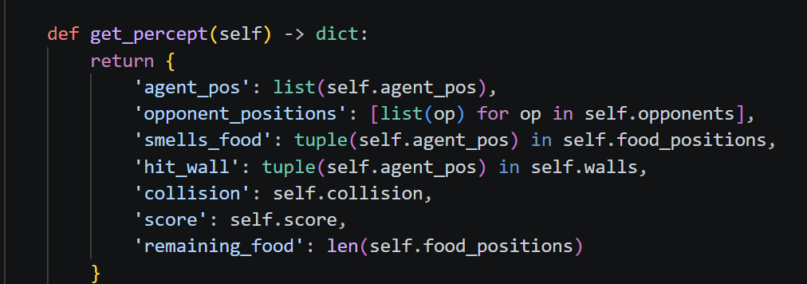
S – Which is sensors
6.
Partially Observable – because the sensory data doesn’t directly say where the food is, it only giving a hint like smells_food function
7.
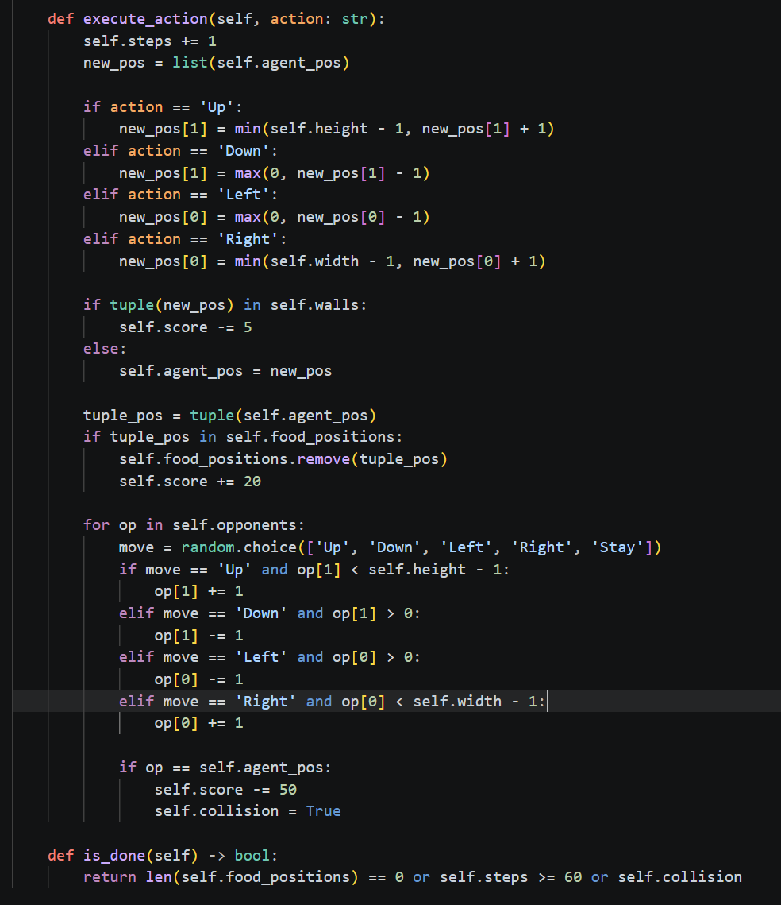
P – Performance Matrices
8.
To be able to make as a security perspective,
Prevent exploits

Part 2
9.
It will limits agents ability to see the traps and he might fall onto those without thinking
10.
In the last question completely not having ability to see the traps is bad than having the ability to atleast not to pinpoint but to at least approximately map the positions of the toxins to avoid it, it actually improve the rationality drastically
11.
Metric exploit happens when the agent finds a loop hole in the system and try to cheese the system and doing works to exploit the system instead of playing withing the given rules

